https://github.com/Waffl3l0v3/event-registration-system-app.git
https://github.com/Waffl3l0v3/e-commerce-app.git
https://github.com/Waffl3l0v3/to-do-list-manager-app.git
https://github.com/Waffl3l0v3/student-management-system-app.git
https://github.com/Waffl3l0v3/task-manager-app.git
https://github.com/Waffl3l0v3/mern-blog-app.git
- Create vnet
  - Subnet A: name subnet-frontend, range 10.0.1.0/24
  - Subnet B: name subnet-backend, range 10.0.2.0/24
- Create NSG — nsg-frontend
  - Inbound
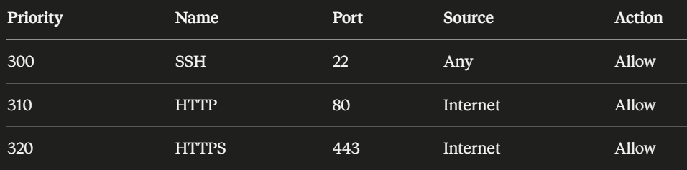
- Create NSG — nsg-backend
  - Inbound
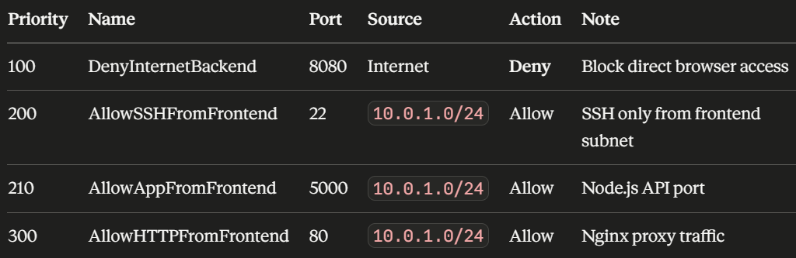
  - Outbound
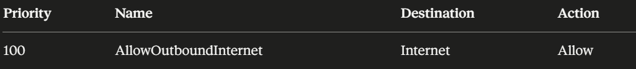
- Create VM — frontend (client)
  - Subnet A
  - Public ip = yes
  - Nsg = none
  - Ports = 22
  - Later add nsg to vm
- Create VM — backend (server)
  - Subnet B
  - Public ip = no
  - Nsg = none
  - Ports = 22
  - Later add nsg to vm
  - Associate public ip to NIC for now
- SSH and Terminal Steps
  - SSH into Frontend from your local machine
  - Copy your private key to the frontend (to reach backend)
// frontend vm
mkdir -p ~/.ssh
// local
scp -i ~/key.pem ~/key.pem client@<FRONTEND_PUBLIC_IP>:~/.ssh/key.pem
  - SSH from Frontend into Backend
// frontend vm
ssh -I ~/.ssh/key.pem server@<BACKEND-PVT-IP>
- Install and Configure - BACKEND VM (server)
  - Update packages
sudo apt update && sudo apt upgrade -y
  - Install Node.js
sudo apt install -y nodejs npm
node -v && npm -v
  - Install PM2 to keep the server running
sudo npm install -g pm2
  - Clone the repository
git clone https://github.com/Waffl3l0v3/<project>.git
cd project
  - nano /server/server.js
// bind to backend ip
app.listen(PORT, "10.0.2.4", () => { console.log(`Server is running on port ${PORT}`); });
  - nano /server/.env
MONGO_URI=mongodb+srv://<username>:<password>@cluster0.thpbswo.mongodb.net/<db-name>?retryWrites=true&w=majority&appName=Cluster0
PORT=5000
  - Install backend dependencies
cd ~/project/server
npm install
  - Start with PM2 so it persists after SSH disconnect
pm2 start server.js --name "<project-backend>"
pm2 save
pm2 startup
- Install and Configure - FRONTEND VM (server)
  - Install dependencies
sudo apt install -y nodejs npm nginx
node -v && npm -v
nginx -v
  - Clone the same repo on the frontend
git clone https://github.com/Waffl3l0v3/<project>.git
cd project
  - nano client/package.json
// Find vite under devDependencies and move it to dependencies
  - nano client/.env
VITE_API_URL=http://10.0.2.4:5000
  - nano client/vite.config.js
… '/api': 'http://10.0.2.4:5000' …
  - Build the React frontend
cd ~/<project>/client
npm install
npm run build
  - Configure Nginx to serve the app
// sudo nano /etc/nginx/sites-available/<project>
server {
listen 80;
server_name _;

root /var/www/<project>;
index index.html;
# Serve React app
location / {
try_files $uri $uri/ /index.html;
}
# Proxy API calls to backend private IP
location /api/ {
proxy_pass http://10.0.2.4:5000;
proxy_http_version 1.1;
proxy_set_header Host $host;
proxy_set_header X-Real-IP $remote_addr;
proxy_set_header X-Forwarded-For $proxy_add_x_forwarded_for;
}
}
  - Enable the config
sudo mkdir -p /var/www/<project>
sudo cp -r /home/client/<project>/client/dist/. /var/www/<project>/
sudo chown -R www-data:www-data /var/www/<project>
sudo ln -s /etc/nginx/sites-available/<project> /etc/nginx/sites-enabled/
sudo rm /etc/nginx/sites-enabled/default
sudo nginx -t
sudo systemctl restart nginx
- Run app in browser
// Frontend VM (client)
http://<FRONTEND_PUBLIC_IP> in browser
- THE END

